2019 Program Director Year-in-Review
2019 proved to be an extremely successful year for The First Tee of Tulsa.
The total number of positively impacted youth jumped to a record-high of 19,360, which marks a 25% growth over the previous year. The First Tee of Tulsa also partnered with 48 youth agencies, which is a record number.
2019 Programming Summary
- 2,078 students attended 8-week programming at one of The First Tee of Tulsa locations.
- 490 students from 2018 attended classes in 2019 for a retention rate of 32.34%.
- Of those 2,078 students, 1,556 were unique.
- Total number of instructional hours equaled 1,098.15.
 | Spring | Summer | Fall | Total
Mohawk | 490 | 678 | 345 | 1,513
Page Belcher | 61 | 80 | 100 | 241
Golf in the Park | 22 | 9 | 54 | 85
Canyons | 36 | 19 | 42 | 97
Tulsa Boy’s Home | 43 | 0 | 55 | 98
Catoosa | 15 | 0 | 22 | 37
Spirit Life | 0 | 0 | 7 | 7
Totals | 667 | 786 | 625 | 2,078
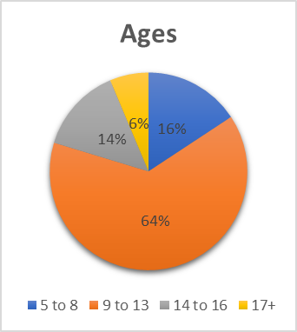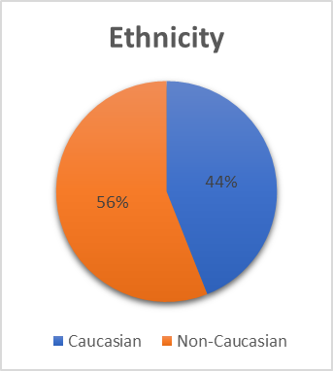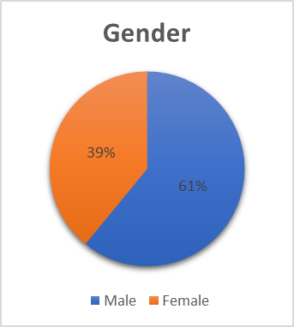
Transportation: In 2019, The First Tee of Tulsa transported 790 students from 20 schools/youth agencies. We traveled a total of nearly 31,000 miles in over 1,000 round trips to transport 38.02% of the students in programming
Outreach:
- National School Program: 9,086 (18 Schools)
- Winter Program: 6,329 (29 Schools)
- Clinics: 1,867

Multiple Sessions: 470 students attended multiple sessions throughout the year. 134 students attended all three sessions, while 336 students attended two sessions.

Overall Demographics: (19,360)

Educational Opportunities
ACT Prep: 14 Students attended a two-day ACT Prep course that consisted of 6 hours of programming.
STEM: Two classes were taught over the course of the year for a total of 12 hours of programming.
Reading and Writing: 14 Students attended a 30-hour academic program taught by professional educators at The First Tee of Tulsa Learning Center at Mohawk.
Math and Leadership: 41 Students have attended this program specifically designed for Marshall Elementary. It consists of 10 classes and over 12 hours of programming.

